Contents
1.0 User Story 2
2.0 Wireframe & UI Requirements 2
3.0 Workflow 3

1.0 User Story
Title: Consolidate User Accounts
As a: | Logged in Lincoln Financial Group customer eligible for account consolidation
I want to: | Consolidate my Mutual Fund Account into my Legacy Brokerage Account
So that: | I can have a simpler investing experience where I can view all my assets under one account
Acceptance Criteria: | - For every user eligible for account consolidation, system displays ‘Consolidate Your Account’ hyperlink on the “Accounts Overview” page  - On click of ‘Consolidate Your Account’ hyperlink, system navigates the user to ‘Consolidate Your Account’ page in the same browser window.  - ‘Consolidate Your Account’ page shall display all the upgrade eligible Mutual Fund Account(s) and the associated Legacy Brokerage Account(s) with the same registration type.  - System shall allow the user to select one or more or all the eligible Mutual Fund Accounts available for an upgrade.  - On Click of ‘Continue’ button, system shall validate that the user has selected one or more eligible Mutual Fund Account(s).  - In the event of user selecting one or more eligible Mutual Fund Account, system shall navigate the user to ‘Review & Submit’ page.  - In the event of the user clicking ‘Continue’ button without selecting any eligible Mutual Fund Account, system shall displays the following inline error message: “Please select an eligible Mutual Fund Account to continue.”  - On click of ‘Cancel’ button, system shall navigate the user to “Accounts Overview” page

2.0 Wireframe & UI Requirements
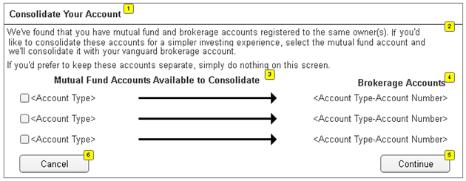
ID | Field Name | Field Type | Content | Default Selection
1 | <Page Title> | Text | Consolidate Your Account | N/A
2 | <Note> | Text | We've found that you have mutual fund and brokerage accounts registered to the same owner(s). If you you'd like to consolidate these accounts for a simpler investing experience, select the mutual fund account and we'll consolidate it with your brokerage account.  If you'd prefer to keep these accounts separate, simply do nothing on this screen. | N/A
3 | Mutual Fund Accounts Available to Consolidate | Check Box | <Account Type> | Unchecked
4 | Brokerage Accounts | Text | <Account Type-Account Number> | N/A
5 | Continue | Command Button | Continue | N/A
6 | Cancel | Command Button | Cancel | N/A

3.0 Workflow

